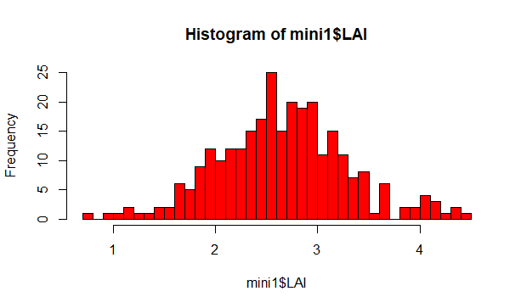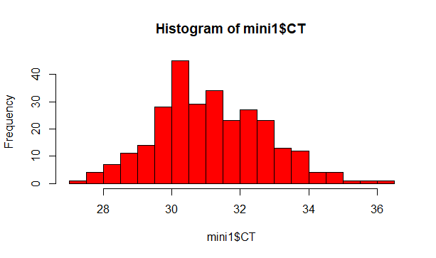

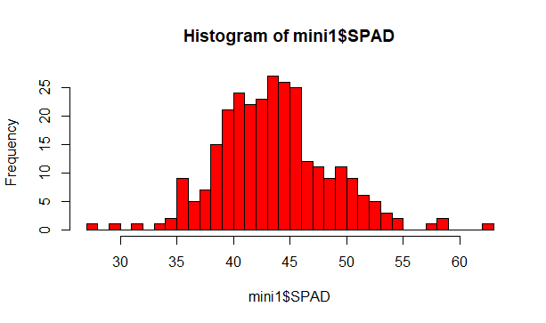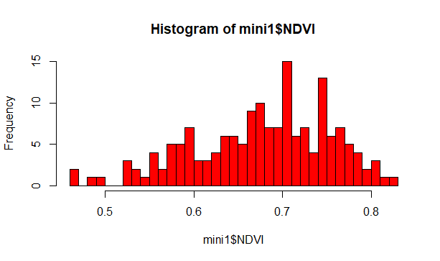
Figure S1: Histogram of BLUP of leaf area index (LAI), canopy temperature (CT), chlorophyll content (SPAD) and NDVI from the groundnut minicore collection.

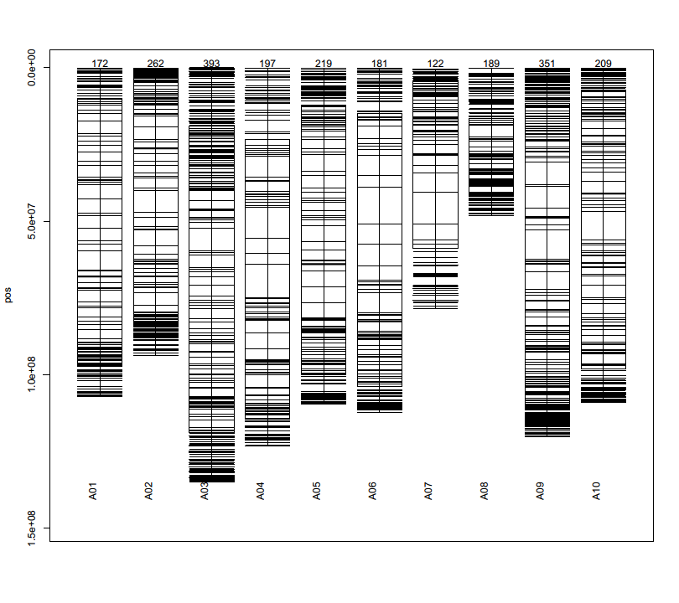
Figure S2: Distribution of markers on B genome of the groundnut accessions

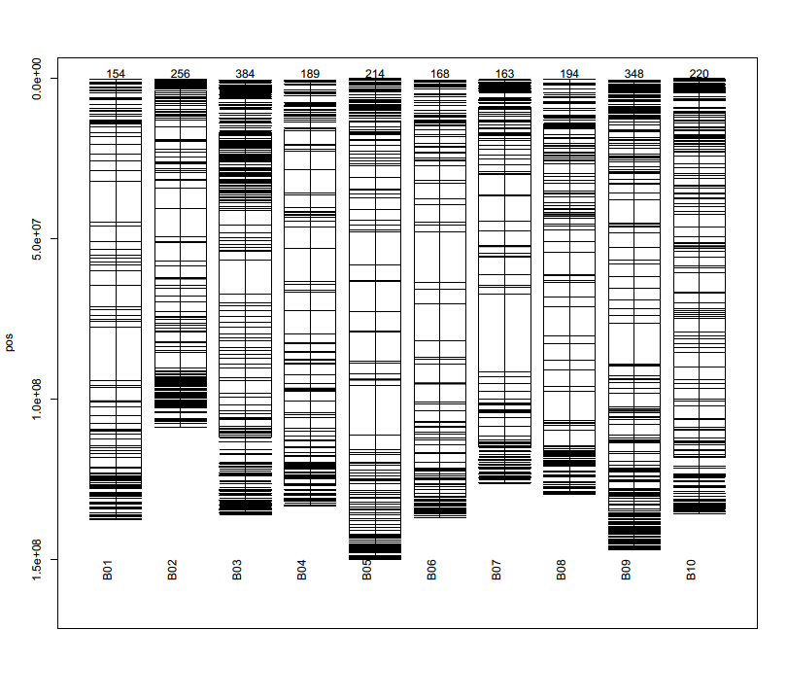
Figure S3: Distribution of markers on the B genome of the groundnut accessions

